Kuhlmeyer delivers a highly automated portal grinding machine type PZM with turning device for the manless grinding and deburring of surfaces on screen baskets and perforated plates

One of the world's leading supplier of plants, equipment and services for the pulp and paper industry, has chosen a multi-functional grinding machine made by Kuhlmeyer engineering. For the production of screen baskets and perforated plates a surface grinding and brushing machine was required to further optimize the production and processes and to make the quality more repeatable.
The realization was done by Kuhlmeyer Maschinenbau from the East Westphalia Bad Oeynhausen. With more then 40 years of experience in grinding, polishing and deburring of wood and metal materials a suitable machine was designed and built for the described application.
In the first phase we have proven the feasibility with various grinding tests. Then it was required to plan the optimum machine layout, to improve the parts handling and material flow. The Kuhlmeyer team has examined various solutions and finally designed a mobile Portal-Twin-Belt Grinding Machine with automatic actuators for the movable machine frame and the tool functions, as well as a blank turning device as a core of the system.

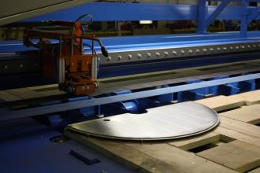 Kuhlmeyer PZM-SO with shaped panel
The very varied components range on sheets of 300 x 1000 x 3 mm up to 2500 x 5500 x 12 mm, including shaped contours, semi-circular shapes and panels with cutouts, must be securely positioned. Since in most cases, both sides of the workpieces have to be machined, the components need to be turned. This is the only way to ensure that the surfaces meet the high quality requirements for the further use of the material.
The turning device equipped with swing clamps and retractable stop pins is positioned as a machine table underneath the grinding machine. Thus, for different components automatically a turn from 0° to 180 ° can be achieved. A secure hold of the sheets is important, so that the automatic operation without interruptions can run proper through to the finished workpiece.

Kuhlmeyer PZM-SO with blank turnover device
We have the ability to move the entire grinding and brushing machine in the X - axis automatically via the machine drive and framework. So we can reach the corresponding points for grinding or necessary setup- and waiting positions. The rail system can easily extended to provide longer strokes or to adapt later on further expansion stages for more flexibility. The rails can also be embedded in the floor to minimize interference edges or tripping hazards.
For Kuhlmeyer the project was interesting, because our design and development team has been looking into the subject of automation and handling of long belt grinding machines. Different approaches and solutions have already been implemented and we were able to build with this project another highlight with a well known German customer.
The production manager of our customers confirms: "We have the substantial advantage that we reach almost an unmanned machining of components in 3 shifts. The high quality in the repeatability of surface finish and simplified part handling for loading and unloading of the machine is more than convincing and our expectations were more than fulfilled. The complex machine is very robust and practical proven, the service is minimal, so that we can plan a high availability of the entire system. "
The user-friendly control based on Simatic S7 is easy to operate with the externally accessible operator terminal. Programs are created quickly in a line form, just the start and reversal points must be defined. Overlaps and speeds of the driving axles are used to achieve the desired surface condition. By means of a remote control, the positions also can be teached in and stored inside the machine safety area with limited access from the operator, which is an additional advantage of the system.
The Kuhlmeyer Portal Twin-belt grinding machine is an evolution of the very reliable and more than 700 times sold Twin-belt grinding machine ZBS. The principle , always to use two abrasive belts or rather, to use one belt for roughing and a second for the finishing , generous traditions and offers great advantages when grinding the surfaces , since no disturbing belt change needs to be scheduled in the production process . This not only saves setup time, but also increases the quality. We also take advantage of the long, endless abrasive belt : the long lifetime, low heating of the belt and the workpiece, the high belt speeds , the possibilities of movement of the belt in order to compensate the corresponding floating tools ( pressure shoe or contact rollers ) also irregularities in the workpiece surface.

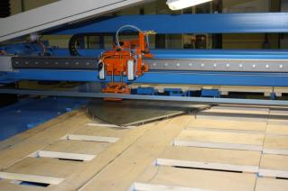 Kuhlmeyer PZM-SO with contact drum in use
By the additional integrated brush head, which is used for deburring of surfaces, particularly at the edges of the drilled and cutouts, receives the PZM another important function, which is usually done by individual machines. With our concept, we could summarize the requirements and optimize the machine movements. This also saves time and money.
With the high level of vertical production, the design office in-house and own control specialists, all machines are completely manufactured, assembled and put into operation in the Kuhlmeyer-plant. Complete solutions from a single source, Made in Germany, individually adapted to the customer requirements.
Finally, a few practical examples :
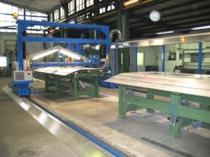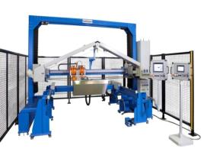
Kuhlmeyer PZM-SO for preparation on outer train panels Kuhlmeyer PZM-Robotec for bulky extraction hoods

For further info please visit us at www.kuhlmeyer.de, on facebook or have a look on our YouTube channel.
_________________________________________________________________________________

Contact :
Kuhlmeyer Maschinenbau GmbH

Martin Stahlberg
Zur Bauernwiese 23
D – 32549 Bad Oeynhausen

Tel. 05731 - 5304-30
E-Mail : m.stahlberg@kuhlmeyer.de
www.kuhlmeyer.de

