Kuhlmeyer expanded its product portfolio with a Single-Belt Grinding Machine
With the new Single-Belt Grinding Machine EBSC ​​has Kuhlmeyer Maschinenbau GmbH, the longtime experienced specialist for long belt grinding machines, expanding its product portfolio with an inexpensive and compact machine.
The new machine was presented at Blechexpo in November 2015 for the first time and has since then a constant high demand.
With the new machine Kuhlmeyer applies in particular to the customers who have just a little space available, who have to process small components and very low lot sizes, but need to integrate a professional and ergonomic belt grinding for machining of welding seams and surfaces in their production.
In addition to the proven grinding unit with contact roller and flat pressure piece keeps Kuhlmeyer a deburring module ready, that can be simply placed on the machine guidings.
With dimensions of 2400 x 1850 x 2000 mm, the EBSC ​​can easily be integrated into existing production structures or as a mobile machine with a stable base and fork-lifter pick-up points quickly and easily adapt to the dynamic production processes.
Many details of the Kuhlmeyer grinders are used in the compact machine, so that the customer can benefit any time from the proven and high-quality construction, as well as from the high-precision manufacturing in Kuhlmeyer quality.
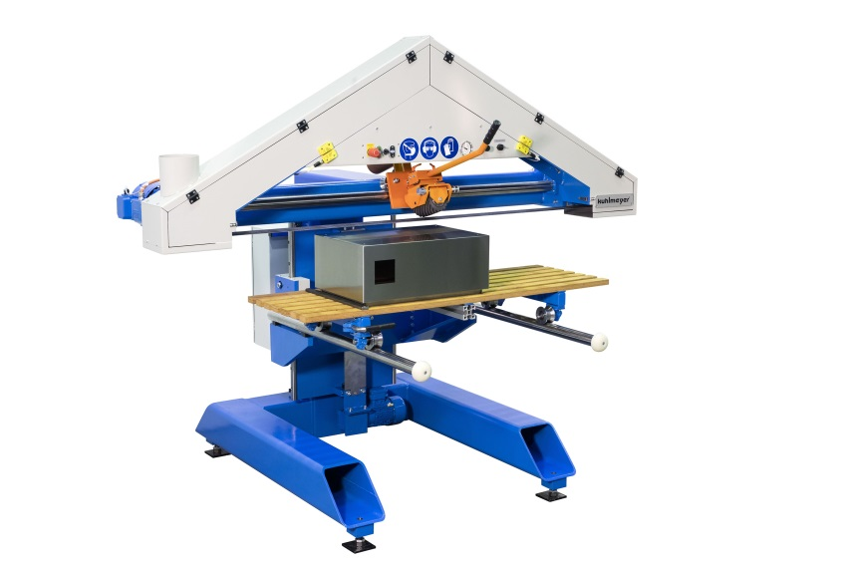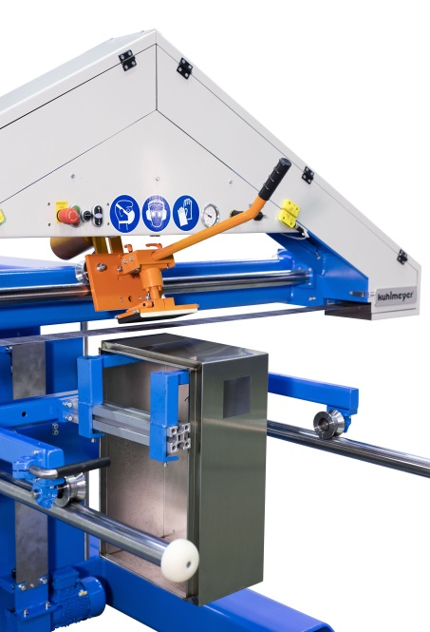

For further information, please visit us atwww.kuhlmeyer.de, on facebook or directly in our showroom.
_________________________________________________________________________________

Contact :
Kuhlmeyer Maschinenbau GmbH

Martin Stahlberg
Director Sales and Marketing
Zur Bauernwiese 23
D – 32549 Bad Oeynhausen

Tel. 05731 - 5304-30
E-Mail : m.stahlberg@kuhlmeyer.de
www.kuhlmeyer.de

Company Background:
Kuhlmeyer Maschinenbau GmbH was established in 1973 and has its HQ in Bad Oeynhausen/Germany. We are a private owned company. On a production space of around 2500 m² we plan and build with 40 experienced employees our belt grinding machines for the metal and wood industry. The main focus is laying on the preparation of the surface on workpieces either manual up to fully automated machines and also the seam weld preparation on blanks with bevelling machines. Hereby we can work on parts up to 16 m length. Kuhlmeyer is supplying the engineering, design, build and installation/ setup on site incl. surrounded periphery installation, i.e. controls, extraction system, conveyor and handling equipment as well as Safety- and Noise-protection housing.
The After-Sales-Service incl. maintenance and spare parts will be managed from our Head Office. For the worldwide sales activities Kuhlmeyer is represented by more the 20 partners worldwide on 5 continents. The deep vertical manufacturing content by the own machine equipment for the total metal working and a unique Training center and Showroom with almost 6 machines in use will complete the companies profile for an experienced and competent partner in the industry.

