October 2014 / September 2015 :
Kuhlmeyer delivers the first fully automated portal grinding system with Robotec handling technology to finish large, complex stainless steel structures after forming and welding eliminating all manual labor.
In the spring of 2014 one of our long standing customers from the USA, a producer of high end kitchen appliances—after an extensive period of detailed trials and research—decided to integrate the first ever delivered Kuhlmeyer PZM – Robotec into his production. By automating the process of finishing formed and welded components, the customer no longer needed manual labor for this task.
The customer already had plenty of experience with the quality of a Kuhlmeyer machine. Over the past 10 years, he had accumulated 12 conventional long belt sanding ZBS machines in several facilities and sub suppliers. While these machines delivered excellent results, there was a need to optimize ergonomics, quality, and throughput for larger kitchen hoods and stove fronts due to the difficulty of staffing the finishing operation of the business. This requires skilled individuals who do repetitive work over extensive periods of time. With this in mind, along with improving safety, the planning and selection of the final configuration began. The results were a final configuration that came with incredible consistency and repeatability of the process.
It was not difficult to select Kuhlmeyer, a midsize German company located in Bad Oeynhausen. Not only do they have extensive experience in polishing, grinding and deburring for metal and wood applications, they are also able to customize with practical solutions. They can adapt quickly to individual customer requirements, mainly with existing proven modules. The R&D team at Kuhlmeyer began designing and testing several different approaches to automation and handling systems on long belt stroke sanding machines already 3 years ago. The preliminary prototype was based on the standard Twin Belt Machine (ZBS). After the customer’s first trial run the necessary improvements were made and Kuhlmeyer achieved the results specified at the beginning of the project.

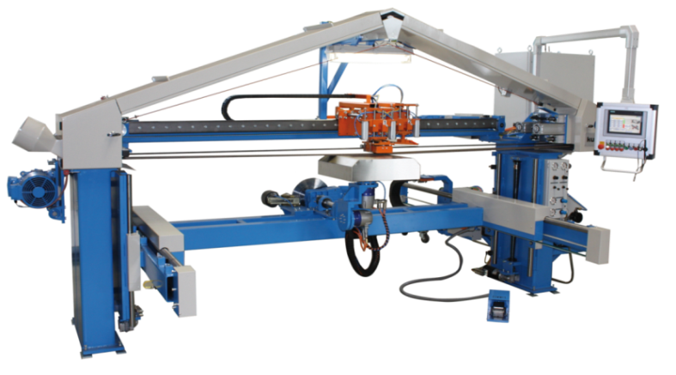

Kuhlmeyer ZBS Robotec
Based on the size of the parts and the acceleration requirements of the individual axis drives it was obvious that the standard ZBS solution would not meet the specifications. The concept switched from the TBS base machine to the Portal Twin Belt configuration (PZM). This offered better access in a significantly larger working range. Furthermore, necessary movement in the vertical Z axis direction was made possible by mounting a much stronger handling unit on a fixed rail with the grinding unit. Now the machine could fully rotate parts up to 1680 mm (66”) under the belt allowing for work on the short sides of long components.
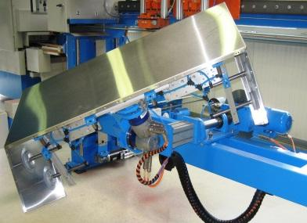 Work Piece: Stainless Steel Enclosure of a Kitchen Hood
The success of the project would not have been possible without the customers involvement in the development of his own specific fixtures, and the extensive trials run on the machine during the development and final assembly of the finished machine. He was able to influence the final shape of the product and as a result the final screen design and translations suits his needs perfectly. His input also helped streamline development. It is also important to note the vision and work performed in the users prior processes. An already excellent TIG welding operation was optimized for consistency and final geometry. It was clear to all participants that the finishing operation would be optimized by the quality of the prior welding process.

Once the new technology had been decided upon, the order was executed. The machine was successfully finished in October 2014 in Kuhlmeyer’s German factory, and subsequently subjected to a detailed acceptance test. All test results were satisfactory, and a punch list with minor changes was worked out before the machine shipped to the USA. Kuhlmeyer’s American factory representative MetalFinish LLC coordinated shipping and import, and installed the machine at the customer’s facility in Wisconsin. Start up, training, and the final acceptance then brought the transaction to a happy ending.
8 months later, the first Robotec has met and exceeded specifications and expectations. After commissioning cycle times were further reduced beyond the data used for justification improving both quality and throughput. This led to a subsequent order for a second system in short time. Shipment for the Robotec 2015 is scheduled for late fall in 2015, and hopefully the machine will be exhibited at Fabtech 2015 for a broad audience.
Here are a few key economic indicators for the productivity of the system which probably will ring true for other users as well. Cycle times were cut by more than half as the output per machine was improved by a factor of 2.7. The quality of the finished product is both improved and of greater consistency by automating the grinding process. The machine operator no longer has to make repetitive movements for extended periods of time, and now has ample time to prepare the work piece for the next automated grinding cycle. Set up and pre-finishing steps are now completed while the cycle is running and therefore don’t reduce output any further. All involved parties agreed that the time spent creating the concept, development and testing of the machine paid off, and that the system now is utilized to its full potential. This, of course, does not exclude further optimization.
The PZM Robotec integrates 10 motorized axis carrying a maximum payload of 110 lbs for workpieces up to 80“ X 20“ X 28“ long. The control, a Simatic S7, has been extended with a second operating panel outside of the guarded hazardous zone for optimum safety and operator convenience. All part programs are programed and stored directly in the control. All programs can be backed up and called up for execution at any time.
A number of parameters such as feed rates, limits, and grinding pressure are vital to a successful application. Actual values are displayed on the screen and can be adjusted on the fly while observing the process. The machine commands 2 separate grinding belts for the first coarse material removal and the final finish reducing belt change times and increasing uptime. The automatic tool motion can be switched off for manual mode increasing the flexibility of the system. The operator for example can equalize uneven welds or remove unexpected spots and scratches from a surface.
can this to go directly to the youtube film clip!

For more information visit us at www.kuhlmeyer.de, on facebook or on our youtube channel.
Scan this to go directly to the youtube film clip!

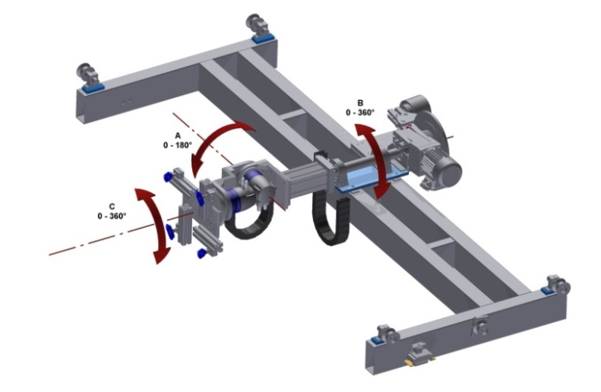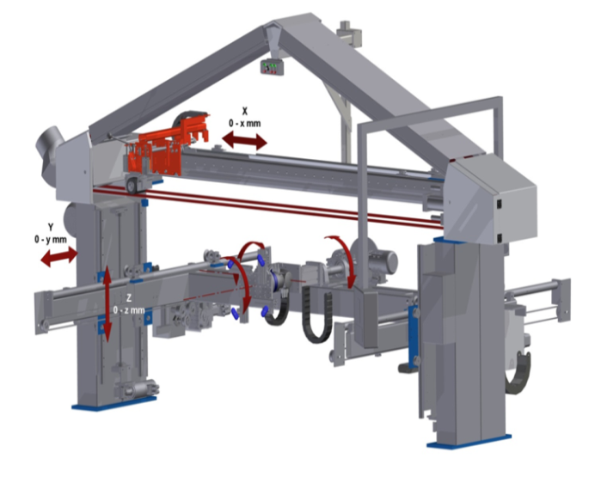

Technichal Data and Features : Basic Machine
 | ZBS 2 | ZBS 3 | PZM 2.2 | PZM 3.2
Working Area/ Table Size | 3.000 mm | 4.000 mm | 3.000 mm | 4.000 mm
Main Power Supply | 4.0 kW | 4.0 kW | 4.0 kW | 4.0 kW
Grinding Belt - Speed | 4 – 25 m/s | 4 – 25 m/s | 4 – 25 m/s | 4 – 25 m/s
X- Axis – Stroke | 3.000 mm | 4.000 mm | 3.000 mm | 4.000 mm

ROBOTEC
 | ZBS | PZM
Y-Axis | 1.000 mm | 1.000 mm
Z-Axis  (dimension from floor to belt bottom side) | 780 mm | 2.200 mm
A-Axis | 0° - 180° | 0° - 180°
B-Axis | +- 180° | +- 180°
C-Axis | 0° - 360° | 0° - 360°

Contact :
Kuhlmeyer Maschinenbau GmbH

Martin Stahlberg / Sales Director
Zur Bauernwiese 23
D – 32549 Bad Oeynhausen

Tel. +49 5731 - 5304-30
E-Mail : m.stahlberg@kuhlmeyer.de
http://www.kuhlmeyer.de
www.facebook.com/pages/KuhlmeyerGmbH

Company Background:
Kuhlmeyer Maschinenbau GmbH was established in 1973 and has its HQ in Bad Oeynhausen/Germany. We are a private owned company. On a production space of around 2500 m² we plan and build with 40 experienced employees our belt grinding machines for the metal and wood industry. The main focus is laying on the preparation of the surface on workpieces either manual up to fully automated machines and also the seam weld preparation on blanks with beveling machines. Hereby we can work on parts up to 16 m length. Kuhlmeyer is supplying the engineering, design, build and installation/ setup on site incl. surrounded periphery installation, i.e. controls, extraction system, conveyor and handling equipment as well as Safety- and Noise-protection housing.
The After-Sales-Service incl. maintenance and spare parts will be managed from our Head Office. For the worldwide sales activities Kuhlmeyer is represented by more the 20 partners worldwide on 4 continents. The deep vertical manufacturing content by the own machine equipment for the total metal working and a unique Training center and Showroom with almost 6 machines in use will complete the companies profile for an experienced and competent partner in the industry.

